**Generations of Wireless Communication**

**1G**

* This is the first generation of wireless telephone technology, mobile telecommunications, which was launched in Japan by NTT (Nippon Telegraph and Telephone Corporation) in 1979.
* It uses Advanced Mobile Phone Service (AMPS) standard.
* Advanced Mobile Phone Service (**AMPS**) is a standard system for analog signal cellular telephone service in the United States and is also used in other countries.
* It uses analog signals.
* It allows the voice calls in one country.
* Speeds up to 2.4 kbps

**Disadvantages**

* Poor quality of voice
* Poor life of Battery
* Size of phone was very large
* No security
* Capacity was limited
* Poor handoff reliability

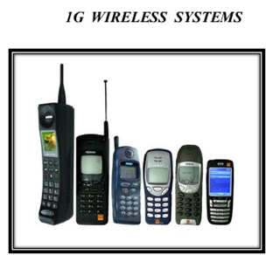

**2G**

* This is the second generation of mobile telecommunication was launched in Finland in 1991.
* It was based on GSM standard.
* The Global System for Mobile Communications (*GSM*) is a standard developed by the European Telecommunications Standards Institute (ETSI) to describe the protocols for second-generation (2G) digital cellular *networks* used by mobile devices (Mobile phone).
* It enables data transmission like as text messaging (SMS - Short Message Service), transfer or photos or pictures MMS (Multimedia Messaging Service), but not videos.
* The later versions of this generation, which were called 2.5G using GPRS (General Packet Radio Service) and 2.75G using EDGE (Enhanced data rates for GSM Evolution) networks.
* It provides better quality and capacity than 1G.
* Data speeds up to 64 kbps.

**Disadvantages**

* Unable to handle complex data such as Video
* Requires strong digital signals

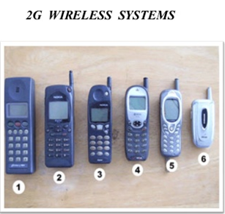

**3G**

* 3G is the third generation was introduced in early 2000s.
* The transmission of data was increased up to 2Mbits/s, which allows you to sending or receiving large email messages.
* The main difference between 3G and 2G is the use of packet switching rather than circuit switching for data transmission.
* Faster communication
* High speed web or more security
* Video conferencing
* 3D gaming
* TV streaming, Mobile TV, phone calls etc. are the features of 3G.

**Disadvantages**

* Costly
* Requirement of high bandwidth
* Expensive 3G phones
* Size of cell phones was very large.

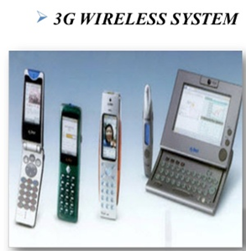

**4G**

* 4G is the fourth generation of mobile telecommunication which was appeared in 2010.
* It was based on LTE (Long Term Evolution) and LTE advanced standards.
* **LTE** is an abbreviation for Long Term Evolution. **LTE** is a 4G wireless communications standard for mobile devices such as phones, tablets, notebook and wireless hotspots
* Offer a range of communication services like video calling, real time language translation
* It was capable of providing 100 Mbps to 1Gbps speed.
* High QoS (Quality of Service) and High security.
* The basic term used to describe 4G technology is MAGIC. Where :  
  M - Mobile multimedia  
  A - Anytime anywhere  
  G - Global mobility support  
  I - Integrated wireless solution  
  C - Customized personal service

**Disadvantages**

* Uses more battery
* Difficult to implement
* Expensive equipment are required

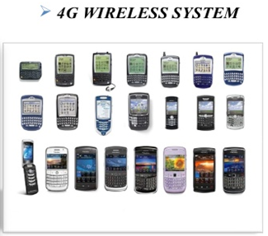

**5G**

* It is referred to fifth generation wireless connection which will be probably implemented by 2020, or even some years earlier.
* Machine to machine communication can be possible in 5G.
* 5G will be able to perform Internet of Things (IoT) for smart home and smart city, connected cars etc.
* This generation will be based on lower cost, low battery consumption and lower latency than 4G equipment.
* There will be much faster transmission rate of data to the previous versions. Thus the speed of 5G will be 1Gbit/s.

